Contents

IS ASSEMBLY LANGUAGE PORTABLE? 2

FAMOUS C HARDWARE TRICKS (A.K.A. CASSEMBLY MOVES) 7

HOW ASSEMBLERS AND LINKERS WORK TOGETHER 11

WHY LEARNING ASSEMBLY LANGUAGE HELPS YOU UNDERSTAND OPERATING SYSTEMS 14

ASSEMBLY LANGUAGE IN EMBEDDED SYSTEMS (WHY IT MATTERS) 20

DEVICE DRIVERS (THE TRANSLATOR BETWEEN OS AND HARDWARE) 24

WHY LARGE APPLICATIONS AVOID ASSEMBLY LANGUAGE 29

THE VIRTUAL MACHINE CONCEPT (VM): EXPLAINED FROM METAL TO MAGIC 33

NOT FOR BEGINNERS 47

This part is left blank.

IS ASSEMBLY LANGUAGE PORTABLE?

**Short answer:** Nope. Not even a little.

But let’s unpack it properly:

**🧳** What is "Portability" in Programming?

A portable language means:

* You write code once 🧑‍💻
* It compiles and runs on different platforms 🖥️💻📱
* You don't have to rewrite everything for each system

Languages like **C++** and **Java** are known for their portability:

* **C++** can compile on many systems (Windows, Linux, macOS), as long as you avoid system-specific features.
* **Java** goes a step further: its compiled .class files run on *any machine* with a Java Virtual Machine (JVM). Write once, run anywhere.

**🛑 But Assembly? Nah.**

Assembly is **tied directly to the CPU architecture.**  
Your .asm file written for x86 (Intel/AMD 32-bit) won’t run on ARM (used in most phones), MIPS, or even x64 without **major rewrites**.

Even different assemblers (MASM vs NASM vs GAS) have different syntax — so there's no "one universal assembly language."

**🧠** Why is Assembly So Inflexible?

* It talks **directly** to the hardware.
* It uses **CPU-specific instructions**.
* It relies on things like **register names**, **stack conventions**, and **memory layout** that vary per system.

**✅** But Here's the Tradeoff:

* Assembly gives you *max control* over what your program does — no layers, no abstractions.
* That’s why it’s still used in:
  + Embedded systems
  + Operating system kernels
  + Bootloaders
  + Malware and exploit development
  + Speed-critical functions inside modern apps

**🔄** Why C/C++ Are "In-Between" Languages:

* C and C++ give you low-level power (pointers, memory manipulation) **without** sacrificing portability.
* You can write fast, near-hardware code in C...
* ...but still compile it for Windows, Linux, ARM, x86, etc. (as long as you don't use platform-specific libraries).

**⚠️ Caveat:**

That low-level power (e.g., using pointers to access hardware memory) **isn’t portable** — because it assumes knowledge of the machine’s architecture.

**🧬** TLDR – Assembly vs C vs Java:

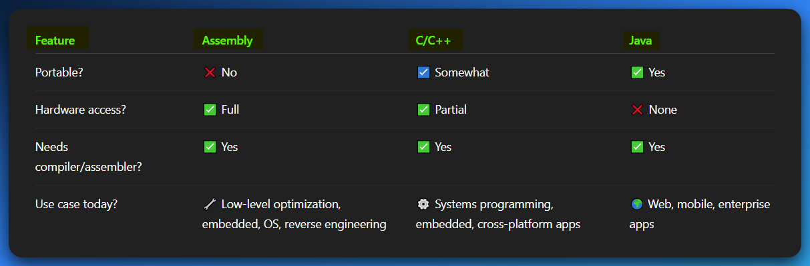

Let’s discuss this part. This is where a *lot* of people (even pros) misunderstand portability.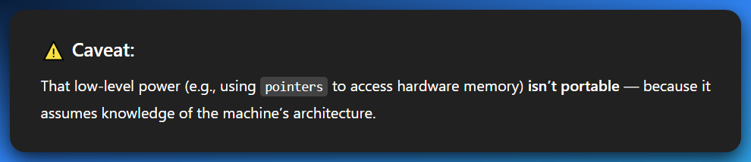

**🧠** What Does It Really Mean to "Access Hardware with Pointers"?

In C or C++, you can write things like:

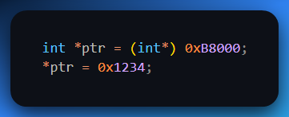

Here’s what that code is *trying* to do:

* You’re saying: “Hey C, treat the memory at address 0xB8000 like it holds an integer.”
* Then you write a value to that exact physical memory address.

This is **direct hardware access** — you’re not asking the OS for permission. You're going **straight to the metal.**

That specific address 0xB8000? On old PCs, that pointed to **video memory** (text mode on VGA screens). So, writing to that memory would literally change what’s shown on the screen.

**⚠️** Why Is That Not Portable?

Because **that memory address only means something on certain hardware, with a specific OS, under a specific configuration.**

Let's say:

* On your PC, 0xB8000 = video memory.
* On a Raspberry Pi? 💥 That address may not even be mapped!
* On a Mac? ❌ Nope.
* On modern Windows in protected mode? ❌ Blocked entirely — you’ll get an access violation.
* On Linux with memory protection? ❌ OS will stop you.

So, while the *C code* is valid everywhere, the **meaning of what it does** completely breaks if you're not on the same low-level architecture.

**💡** Portable vs Non-Portable Code in C

**✅** Portable Example:

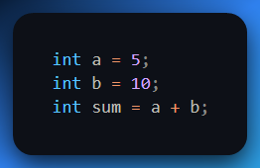

This will work on any machine with a C compiler — no hardware-specific stuff involved.

**❌** Non-Portable Example:

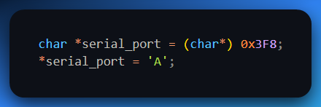

This assumes the serial port is mapped to address 0x3F8 — true on legacy IBM PC architecture, but absolutely **not guaranteed** anywhere else.

**🔐** Why This Matters:

High-level code is like:

**“OS, please print this text.”**

Low-level code is like:

**“I’m writing directly to memory address 0xB8000. Don’t ask questions.”**

If that address doesn’t do what you expect on another system — or the OS won’t let you touch it — your program crashes, or worse, does *nothing.*

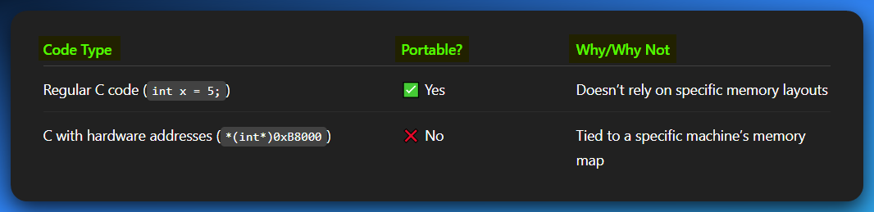

Try going to playstore, download Coding C/C++ app, and copy paste WinAPI code from github. See the results? **windows.h** not found.

So yeah — you *can* write super low-level stuff in C... but the moment you hardcode a memory address or talk to a register, you're in **non-portable, system-specific territory.**

You're basically writing assembly in C syntax — aka **\*Cassembly\*** — non-portable, hardware-hugging madness. It's C with a CPU accent. 😅



*If you didn’t laugh at my joke, just go start at chapter 1 please… You’re my lost sheep.*

FAMOUS C HARDWARE TRICKS (A.K.A. CASSEMBLY MOVES)

These are the OG tricks C programmers used to talk *directly* to hardware — fast, dirty, powerful… but wildly non-portable.

1. Direct Video Memory Writing

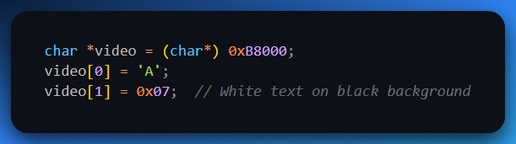

🧠 **What it did back then:**

* Writes the character 'A' to the top-left corner of the screen in text mode.
* 0xB8000 was the **start of the video buffer** on old x86 machines (VGA text mode).

💥 **Why it breaks now:**

* Modern OSes (Windows, Linux) don’t let you directly write to video memory.
* You’ll get a **segmentation fault** or **access violation**.
* This only works under DOS or a protected bare-metal environment.

2. Triggering the PC Speaker (Beep!)

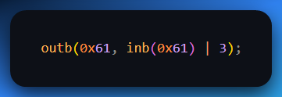

🧠 **What it did:**

* Played a sound through the PC speaker by manipulating the Programmable Interval Timer (PIT) and speaker control register (I/O port 0x61).

💥 **Why it breaks:**

* inb() and outb() are low-level assembly-like instructions.
* Needs kernel-level privileges — user-mode apps can’t do this anymore.
* On modern systems, access to I/O ports is blocked unless you’re in kernel or using a driver.

3. Accessing CMOS/BIOS Data

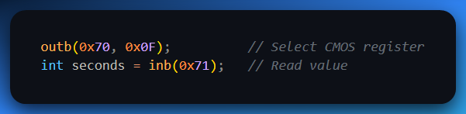

🧠 **What it did:**

* Pulled hardware data (like system time) directly from CMOS.
* You’re basically talking to the BIOS firmware directly.

💥 **Why it breaks:**

* Direct port I/O isn't allowed in protected/user mode.
* You need root-level access, kernel modules, or special drivers.
* OSes abstract this behind proper APIs now (e.g., time.h in C).

4. Writing to Segment Registers (like FS/GS)

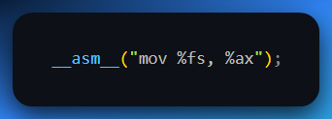

🧠 **What it did:**

* Accessed segment registers for thread-local storage or direct memory addressing.

💥 **Why it breaks:**

* Segment registers work very differently in 64-bit mode.
* Direct access is blocked or repurposed (e.g., FS/GS in Windows are used for TLS).
* You can't just poke these anymore without triggering exceptions.

5. Writing Your Own Interrupt Handler

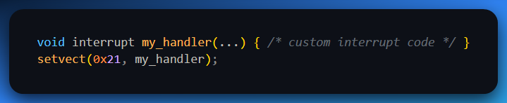

🧠 **What it did:**

* Replaced hardware interrupt vectors with your own handlers.
* Used for keyboard hooks, mouse input, or custom drivers in DOS.

💥 **Why it breaks:**

* Totally forbidden in modern OSes.
* Protected mode + multitasking OS = kernel handles interrupts now.
* You’d need to write a **kernel driver** to do this on Windows/Linux.

**📉** Bottom Line:

These C tricks:

* Worked great in DOS or embedded bare-metal
* Fail hard on modern OSes
* Were basically **assembly disguised as C**

**💡 That’s Cassembly in action:**

Fast, dangerous, thrilling... and completely non-portable.

**🧠** Why Assembly (and Low-Level C) Isn’t Portable

When you write C or Assembly that talks directly to hardware or memory addresses — like poking a specific I/O port or writing to a fixed memory location — it might work beautifully on *your* system...

But take that same code to another machine? 💥 Crash. Burn. Undefined behavior.

**⚠️** Here’s Why:

* *Different systems have different memory layouts (RAM, ROM, mapped devices).*
* *What’s safe on one CPU can be dangerous on another.*
* *That address you wrote to? Might not even exist on a new motherboard or OS.*

Now let’s say you were being a boss in C:

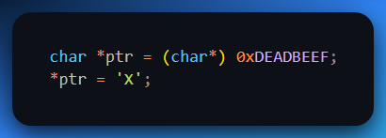

* On your retro dev board? Might write to a screen buffer.
* On a modern Linux laptop? **Segmentation fault**.
* On a microcontroller? Maybe it resets your CPU. Who knows. 🧨

**🔐** Security & Portability: Why We Don’t Do That Anymore (Usually)

In modern systems:

* **Direct hardware access = blocked** (by the OS or CPU).
* **Random memory access = forbidden** unless you’re writing a kernel driver or OS component.

To stay *safe* and *portable*, modern C/C++ code uses:

* **Standard Libraries** – like stdio.h, stdlib.h, fopen() instead of talking to disk I/O directly.
* **System Calls/APIs** – abstracted OS-level functions that handle hardware safely.

These give you a *standard interface* that works on Windows, Linux, macOS, etc.

**🔌** BUT… C/C++ Still Lets You Plug into the Matrix

Many C/C++ compilers let you mix in inline assembly **(__asm__)** or write separate .asm files. That’s the *hybrid zone* — high-level comfort, low-level power. This is where C starts sounding like:

**“You’re basically writing Cassembly — C with bare metal energy.** ⚡**”**

HOW ASSEMBLERS AND LINKERS WORK TOGETHER

Let’s simplify the whole flow of building an executable from .asm source code:

**🏗️** Step-by-Step Pipeline

Assembler: Converts Assembly to Object File (.OBJ)

Reads your .asm file.

Translates mnemonics (MOV, ADD, etc.) into machine code (binary instructions).

Generates a .obj file (not runnable yet).

Adds **relocation info** – placeholders for stuff like:

* “Jump to that function later”
* “This variable will be defined elsewhere”
* “We’ll plug in the correct address later”

Linker: Combines Object Files into Executable (.EXE)

Takes one or more .obj files and library code.

**Resolves all external references**: Fills in the correct memory addresses for jumps, calls, symbols.

**Handles libraries** e.g. If you use printf, the linker connects your code to the standard C library version of it.

May also:

* Merge duplicate sections
* Optimize memory layout
* Create program headers and relocation tables

Final Result: Executable File

Can be run by the OS.

Has all addresses fixed up, everything packed and ready.

**🧠** Summary – The Whole Flow:

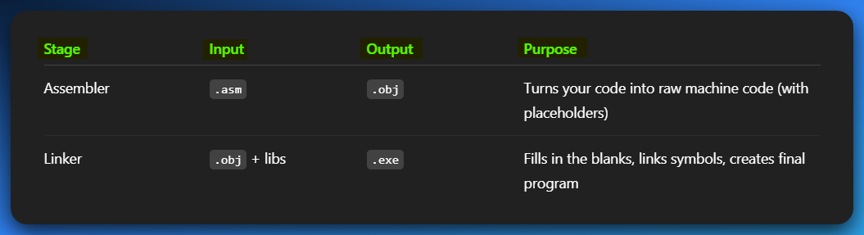

This process — from writing hardware-aware C/Assembly code, to compiling, assembling, and linking — is what gives you full control over the machine... **but only if you respect the rules of the hardware you're targeting.**

**✅** Summary of What We Already Handled:

1. 🧠 **Memory Architecture Differences:**
   * Different systems have different memory layouts.
   * Direct memory access (like poking address 0xB8000 for video) might crash or misbehave on systems with a different architecture.
2. 🔐 **Security & Safety Limits:**
   * C/C++ lets you touch raw memory (via pointers), but OSes and runtime environments (especially modern ones) *won’t always let you* access those addresses directly.
   * Sandbox or protected environments (like in macOS or modern Linux distros) block or restrict direct hardware poking.
3. 📦 **Why Standard Libraries Exist:**
   * To make C/C++ *portable* across systems, the languages offer system libraries (like stdio.h, stdlib.h, unistd.h, etc.) that abstract away low-level differences.
   * Instead of directly touching I/O ports or memory, you use those APIs and the OS handles the dirty work underneath.
4. 🔧 **Inline Assembly Option:**
   * If you *really* need hardware-level control (like writing device drivers or fast math), most compilers like GCC and MSVC let you embed inline assembly inside C/C++ code.
   * But that kills portability — so use it wisely and only when you *need to go full savage mode*. 💥

Assembly isn’t just nerdy ancient tech — it’s a secret key to really mastering operating systems.

WHY LEARNING ASSEMBLY LANGUAGE HELPS YOU UNDERSTAND OPERATING SYSTEMS

If you're serious about leveling up your OS knowledge — assembly isn't just useful... it's a *requirement*. Here's why:

1️) Assembly Shows You the *Exact* Link Between Software and Hardware

* High-level languages like C and Python abstract away the hardware.
* Assembly lets you see what’s *really* happening when a program talks to the CPU, memory, or hardware.
* Why does that matter for OS dev? Because **operating systems *are* the bridge** between hardware and user programs.
* You start to realize that even high-level "OS features" like file systems and multitasking rely on raw instructions underneath.

🛠️ *When you know assembly, you understand the guts of I/O, interrupts, device drivers — all the stuff OSes manage daily.*

2️) System Calls Aren’t Magic Anymore

* Every time you use a function like printf(), read(), or malloc(), it *eventually* makes a **system call**.
* A system call is like your program politely knocking on the OS’s door saying: “Hey kernel, I need help.”
* Assembly shows you **how** that knock happens:
  + On Linux x86_64: it's **mov rax, syscall_number → syscall**
  + On Windows: it's often **int 0x2e** or **syscall** via special **wrappers**
* Instead of just using system calls blindly, you start to *see* how the OS traps into kernel mode, does work, then returns control.

🔍 *Knowing how syscalls are built and triggered is gold for reverse engineering, kernel hacking, or even writing your own OS.*

3️) You Learn How Memory Is *Really* Managed

* Want to understand the stack? Heap? Segments? Paging? Virtual memory?
* Assembly shows you all of it *raw*.
* You’ll watch the stack pointer (RSP) move as functions are called.
* You'll see how memory is addressed, aligned, allocated, or freed — not by magic, but by very specific CPU operations.

📦 *Memory management is a foundational OS task. Assembly shows how malloc, stack overflows, and segmentation faults really happen.*

4️) Performance Optimization Hits Different

* Ever wonder why some low-level functions are so fast or why loops slow down your app?
* Assembly gives you direct access to the CPU’s power.
* You can:
  + Eliminate unnecessary instructions
  + Use SIMD (like SSE or AVX) for vector math
  + Tune cache hits/misses by adjusting memory access patterns

⚡ *The OS scheduler, the memory allocator, and I/O subsystems are all performance-critical — and often written in (or close to) assembly.*

5️) Security: Know the Exploits Before They Know You

* Buffer overflows. ROP chains. Shellcode injection. Stack smashing.
* These aren’t abstract bugs — they’re **assembly-level manipulations** of memory and control flow.
* When you read disassembled malware or debug a crash, you’ll *see* the exploit happening in real time — only if you know assembly.

🛡️ *Modern OS security starts with assembly: you can’t defend or patch what you don’t understand.*

**🧠** TLDR:

Learning assembly is like opening the back door into the OS. You see the CPU, memory, and system calls naked — no high-level sugarcoating. It's not optional if you want to:

* *Build an OS.*
* *Write efficient kernel modules or drivers.*
* *Reverse engineer and debug at the lowest levels.*
* *Truly grasp how programs run and interact with hardware.*

Assembly makes you dangerous (in a good way). 🔧💣

**🧠** ONE-TO-MANY RELATIONSHIPS (High-Level vs. Low-Level)

**What does "one-to-many" mean?**  
When you write a single line of high-level code (like in C, Java, or Python), that line may turn into **multiple low-level instructions** when compiled. That’s the *one-to-many relationship* in action.

**⚡️** Example:

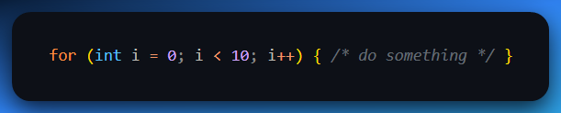

You see one loop? The CPU sees:

* Set i = 0
* Compare i < 10
* If not true → jump out
* Execute body
* Increment i
* Jump back up  
  **= multiple machine instructions.**

🧩 Why?  
High-level languages are like giving directions in full English:

**“Drive 5 blocks, turn left, stop when you see the red house.”**

Assembly and machine code are like telling a robot:

* Move forward 5 units
* Rotate 90°
* Evaluate sensor for red pixel density
* Halt if threshold reached

📌 **So yeah:** high-level is for humans. Machine code is for robots. Assembly is the go-between that speaks human-ish robot.

**🌍** PORTABILITY

**Portability = write once, run (almost) anywhere.**

This means your program doesn't depend on the quirks of a specific CPU, OS, or hardware. The more portable your code is, the less painful it’ll be to move it between machines or systems.

**🚀** Languages Known for Portability:

* **Java:** Compile once, run anywhere (thanks to the JVM).
* **Python:** Interpreted on any system with Python installed.
* **C++:** Portable *if* you avoid system-specific stuff (e.g., Windows-only libraries).

But...

**❌** Assembly is NOT portable.

💡 Why?  
Assembly is written specifically for a CPU’s **instruction set** (ISA). That means:

* **x86 Assembly** won't run on **ARM**
* **Motorola 68k Assembly** won’t run on **VAX**
* Even **x86 Assembly** might differ a bit between 16-bit, 32-bit, and 64-bit modes

It’s like writing music for a piano and trying to play it on a trumpet — the notes don’t match.

**💥** KEY TAKEAWAYS — AS NOTES (High-Level vs Assembly)

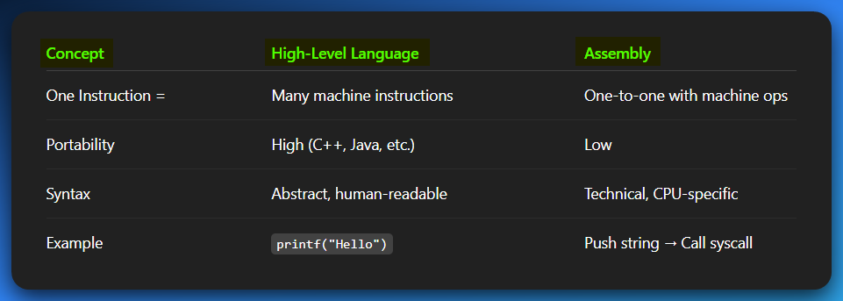

1. Instruction Mapping:

In high-level languages, one line of code can turn into **many machine instructions**.

Example: for (i = 0; i < 10; i++) becomes multiple steps like init, compare, increment, jump, etc.

In assembly, each instruction is usually a **direct 1-to-1 match** with the CPU's machine instructions.

Example: MOV AX, BX → 1 machine instruction.

2. Portability:

High-level languages like **C++, Python, Java** are **portable**. You can write once and run on many systems (as long as you don’t use OS-specific hacks).

Assembly is **not portable**. It’s tightly linked to the CPU architecture it was written for.

Write for x86, and it won’t work on ARM, VAX, or Motorola 68k — each has its own assembly language!

3. Syntax & Readability:

High-level languages are **human-readable and abstract**. You work with concepts like variables, loops, objects.

Assembly is **low-level and technical**. You deal with registers, memory addresses, and CPU-specific operations.

High-level: **printf("Hello")**Assembly: **push "Hello" → call write_string → interrupt or syscall**

4. Purpose:

High-level is for writing apps, websites, APIs — stuff normal devs do.

Assembly is for **low-level optimization**, **OS development**, **reverse engineering**, **malware analysis**, and **hardware hacking**.

ASSEMBLY LANGUAGE IN EMBEDDED SYSTEMS (WHY IT MATTERS)

Assembly language might feel ancient, but it’s still *very alive* in the world of embedded systems — especially where performance, size, and control matter. Here's how:

**🚪** 1. Smart Home Devices

* Examples: Smart thermostats, security alarms, smart door locks.
* Why Assembly? These devices need to **run fast**, **use low power**, and **respond in real-time**.
* Assembly is used to program their **microcontrollers** (tiny CPUs) to handle tasks like sensor readings, Wi-Fi communication, and triggering alarms.



**🏥** 2. Medical Devices

* Examples: Pacemakers, blood glucose monitors, infusion pumps.
* Why Assembly? In medical tech, **timing and accuracy** are critical.
* Assembly ensures **precise control** over hardware like pumps or sensors, which is hard to guarantee in high-level languages alone.
* These systems often have limited hardware (low RAM, slow CPU), so Assembly is used for the most performance-critical routines.



**🚗** 3. Automotive Systems

* Examples: Engine control units (ECUs), brake systems, airbags, infotainment.
* Why Assembly? Cars today are rolling computers. Each function is often controlled by its own **embedded processor**.
* For real-time operations like **airbag deployment or anti-lock brakes**, Assembly code ensures microsecond-level control with **predictable timing**.

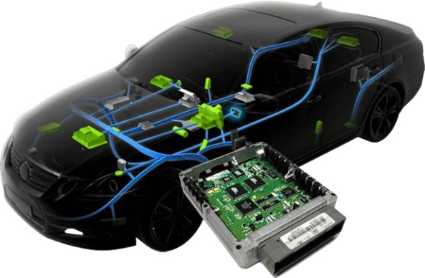

**🏭** 4. Industrial Control Systems

* Examples: Temperature controllers, robotic arms, automated conveyor belts.
* Why Assembly? These systems operate in environments where **stability, precision, and speed** are non-negotiable.
* Assembly provides the low-level hooks to interact with **actuators, motors, and sensors** — making it ideal for factory automation.



**🎮** 5. Consumer Electronics

* Examples: Digital cameras, smartphones, handheld gaming consoles.
* Why Assembly? For **battery life**, **smooth performance**, and **tight hardware integration**.
* In many of these devices, **Assembly is used alongside C** to fine-tune things like:
  + Image processing speed
  + Touchscreen response
  + Audio/video decoding



**🧩** TLDR

* 🪛 Assembly = Total control, speed, minimal memory use.
* 🧠 Embedded = Tiny computers with tight constraints.
* 💡 Perfect match for performance-critical or real-time systems.
* ⚠️ Most embedded software is a **hybrid**: high-level (usually C) + low-level Assembly for bottlenecks.

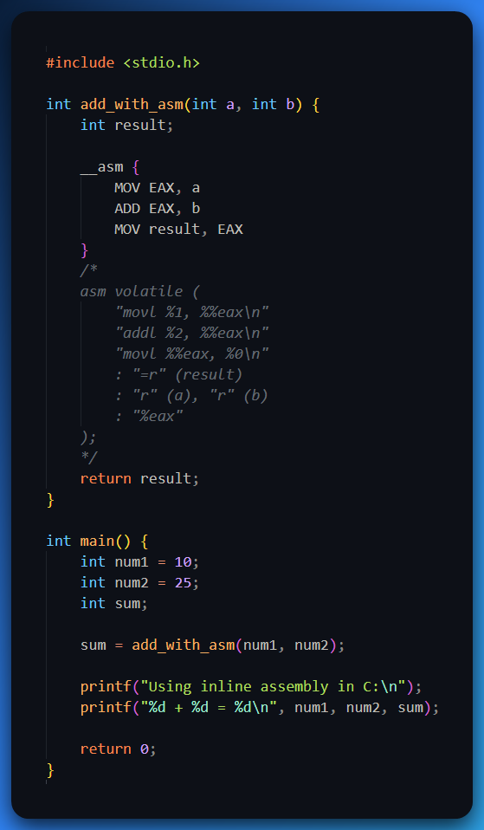

DEVICE DRIVERS (THE TRANSLATOR BETWEEN OS AND HARDWARE)

What is a Device Driver?

A **device driver** is like a translator that helps your operating system talk to hardware.  
Without it, your OS would stare blankly at your keyboard, mouse, printer, or GPU — clueless.

What It Does:

* Converts **OS-level commands** into **device-specific instructions**.
* Acts as the middleman between **hardware** and **software**.
* Enables the OS to **send data to** and **receive data from** the hardware.

Key Points:

* ✅ Written by **hardware manufacturers** for specific devices.
* ✅ Must match the **target OS and version** (e.g., Windows 10 x64).
* ❌ Without a driver, the OS won’t recognize or control the device at all.

Real-World Example:

* You plug in a new gaming mouse.
* Windows doesn’t immediately know how to handle its DPI settings, RGB lights, or side buttons.
* The driver (auto-installed or downloaded) bridges the gap, giving the OS the "vocabulary" to control it.

POINTER TYPE CHECKING – C/C++ vs Assembly

C/C++ – Strong Typing

In C/C++, **pointer variables are typed**. Example: **int* ptr;** means **ptr** is only supposed to point to an integer.

The compiler **checks types at compile-time**, preventing mismatches.

If you try to assign an **int\*** to a **char\*** without a **cast**? ❌ Compilation error or warning.

✅ **Benefits:**

* Catch bugs early.
* Help the compiler optimize better.
* Improve readability and maintainability.

Assembly – No Typing, No Safety Net

In assembly, pointers are just **raw memory addresses**.

There’s **no concept of "type"** — just bits at an address.

You, the programmer, are 100% responsible for:

* Interpreting memory correctly.
* Knowing how many bytes to read/write.
* Not corrupting adjacent memory.

⚠️ **Result:**

* Maximum **freedom**, but also maximum **risk**.
* Easier to mess up memory access (wrong type, wrong size, wrong offset).

**🧠** TLDR:

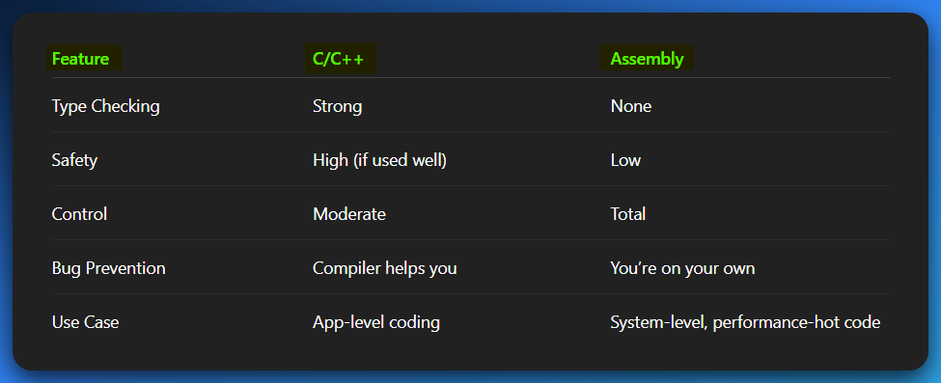

Where Assembly Shines

The two **killer applications** for assembly, and then we’ll explain why high-level languages suck at hardware-level stuff like printers.

1. Operating System Components (Low-Level Core Stuff)

If you're building **device drivers**, **bootloaders**, or anything that’s *literally talking to the CPU/hardware*, then assembly becomes your best friend.

📌 **Why Assembly?**

* Direct control of CPU registers, ports, and memory.
* Zero abstraction = maximum performance.
* Needed for writing things like:
  + Keyboard/mouse drivers.
  + File systems.
  + BIOS routines.
  + Custom kernel modules.

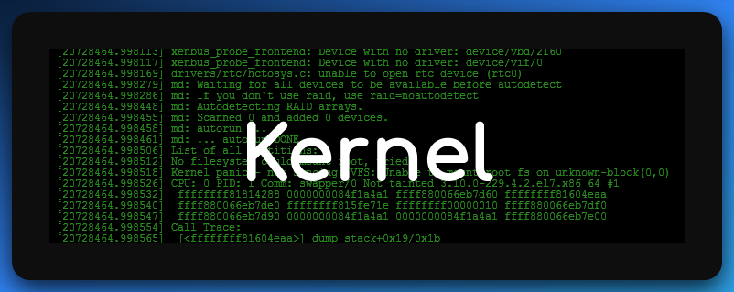

2. Real-Time Systems (Timing is Everything)

In robotics, industrial control systems, or embedded sensors — **every nanosecond counts**. Assembly gives you precise timing and tight control.

📌 **Why Assembly?**

* Deterministic execution (you know *exactly* what happens, when).
* No OS delay or abstraction overhead.
* Used in:
  + Microcontrollers in drones, washing machines, smart TVs
  + Medical devices like pacemakers
  + Automotive ECUs (engine control units)

💡 *Example:* A robotic arm waiting for a signal **must not** miss it or delay due to Java garbage collection. Assembly gives it real-time discipline.

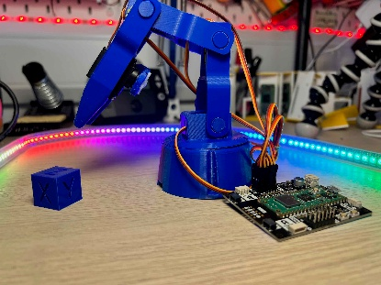

**⚠️** BUT... Assembly is also:

* Harder to write
* Painful to debug
* Tough to maintain
* Super hardware-specific (non-portable)

So, it’s only worth it **when you really need that bare-metal control**.

Why High-Level Languages (HLL) Can’t Handle Printers Directly

**TLDR: Too much abstraction, not enough power.**

📌 High-level languages (like Python, Java, C#):

* Focus on **portability** and **readability**
* Don’t let you touch raw hardware addresses or I/O ports
* Usually **run in a sandboxed/managed environment** (e.g., JVM, Python interpreter)

That means you *can’t just poke a hardware register* or read from 0x3BC to talk to a printer.



Real Talk – Direct Printer Access Needs:

* Writing to **specific I/O ports**
* Managing **hardware interrupts**
* Knowing **low-level specs** of the printer interface (LPT1, USB protocols, etc.)
* Timing & bit-level precision

All of this is abstracted away (hidden) in high-level languages.

💥 **But in Assembly or C?**  
You can just do:

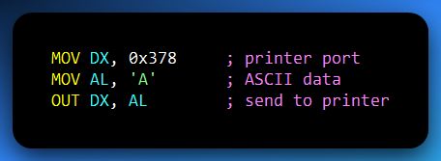

And boom — data sent.

🧠 Summary Recap:

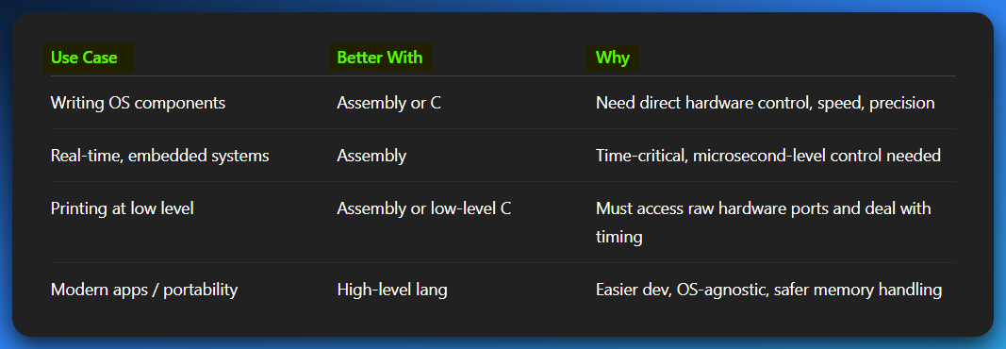

WHY LARGE APPLICATIONS AVOID ASSEMBLY LANGUAGE

**TLDR:** Assembly is a power tool — but not for building skyscrapers. It’s great for small, performance-critical parts of software. But when you’re coding up huge systems (like Photoshop, Chrome, or a game engine), you want power *and* maintainability.

**💣** 1. It’s Too Complex for Large Codebases

Writing in assembly is like writing a novel… using only a typewriter and binary.  
Every line is manual. Every mistake can break everything.

* You manage memory manually.
* You control every CPU instruction.
* A simple for loop in C might be 10+ lines in assembly.

🧠 **Imagine writing a whole GUI app like that. Pain.**

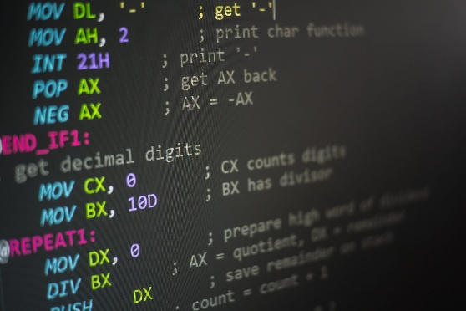

**📉** 2. Assembly = Low Maintainability

Try coming back to your 10,000-line assembly code after 6 months. You’ll cry.

* No function names, no classes, no modules — just labels and jumps.
* It’s like trying to understand a maze without a map.
* Collaborating with others? **Forget it unless you're all wizards**🤧🤣

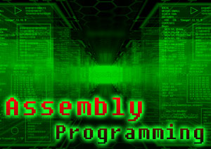

**🚫** 3. No Portability

Assembly is **tied to the CPU architecture** — what works on x86 won’t work on ARM or RISC-V.

💡 If you write assembly for Intel processors:

* Won’t run on a Mac with ARM chips (Apple Silicon)
* Won’t run on your Raspberry Pi without rewriting everything

Big apps need to **run everywhere**, not just one chip.



**🐌** 4. Slower Development = Lower Productivity

Assembly takes *forever* to write. For every one line in C++, you might write 5–10 in assembly.

* No fancy features like classes, templates, or error handling.
* You’ll be stuck solving the same problem for hours that C solved in one line.

With high-level languages, you focus on **what** to do.  
With assembly, you focus on **how the CPU should do it** — every tiny step.



**🪲** 5. Debugging Is Rough

Debugging in assembly is like **looking for a black cat in a dark room with no flashlight**.

* No variable names, just raw memory addresses and registers.
* One wrong jump or misaligned instruction? Instant crash.
* No rich debugging tools unless you write your own.



**😬** 6. You’re On Your Own — Hello Human Error

Everything is manual:

* Want to allocate memory? You do it.
* Want to pass arguments to a function? Manually push to the stack or use registers.

One off-by-one error = **segfault** or corrupted memory.

There’s no compiler yelling “hey that’s unsafe.” You’re the compiler now.

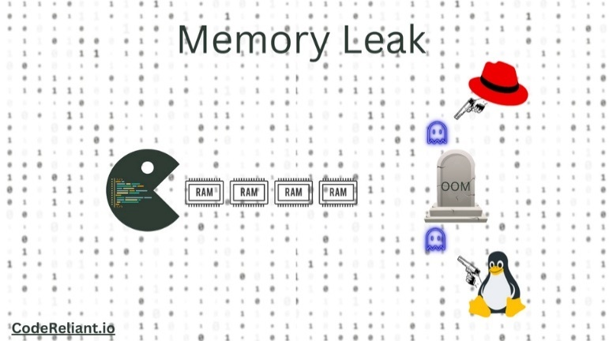

**🔍** Bottom Line

Assembly is a **surgical tool,** not a hammer. It’s perfect when:

* You’re writing performance-critical code (e.g. cryptography, compression, kernel)
* You’re writing firmware, bootloaders, or BIOS routines
* You need to reverse-engineer something or do low-level debugging

But for full applications?

**Use high-level languages. Then, optimize with assembly *only where needed*.**

THE VIRTUAL MACHINE CONCEPT (VM): EXPLAINED FROM METAL TO MAGIC

1. What Is a Virtual Machine (VM)?

At the core, a **Virtual Machine** is like a **fake computer** — a *simulated environment* that *acts like a real machine*. It pretends to be a CPU or OS, but it's actually just software running on top of real hardware.

Think of it like this:

**Your real CPU → runs a fake CPU (VM) → which runs fake instructions (VM code)**

This fake CPU lets you:

* Run code that doesn’t match the real CPU’s language
* Add layers of **abstraction** (complexity control)
* Support **portability** and **security**

2. The Language Stack (From L0 to L∞)

Computers execute **machine code** — this is called **L0**, the "Level Zero" language. But L0 is brutal: pure binary, cryptic, hardware-specific. So, we start building up friendlier layers:

Levels of Programming — From Bare Metal to High-Level Magic:

Level 0 – Machine Language

This is the **rawest form of code** your CPU understands: pure binary — ones and zeros like 10101010.  
No variables, no names, just instructions encoded in bits.

It runs **directly on the physical CPU**, without any translation or processing.

Writing or reading this manually is practically impossible unless you’re a **cyborg.**



Level 1 – Assembly Language

Assembly is the **human-readable layer over machine code**. Instead of writing binary, you write things like:

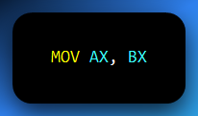

This is a **one-to-one mapping to machine instructions,** but now it uses symbolic names (like registers and opcodes).

It runs through an **assembler** or an **emulator** (like NASM or x64dbg’s built-in disassembler) that converts it into actual machine code.

You're still very close to hardware here — you control memory, registers, the stack, everything.

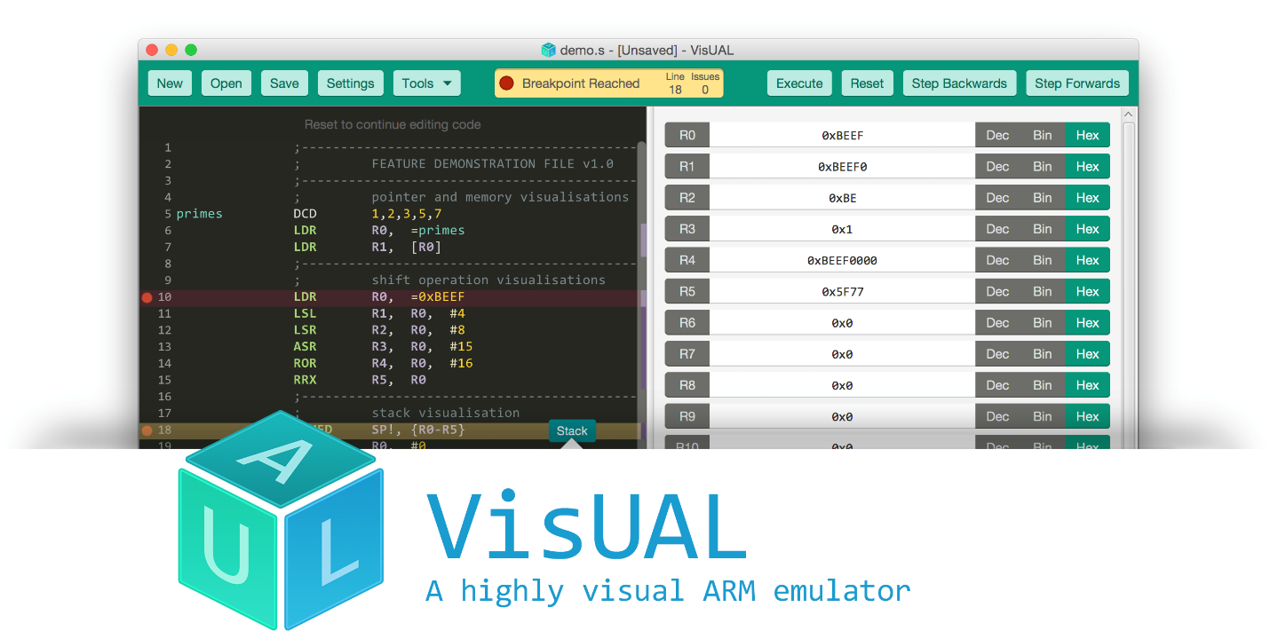

Level 2 – C, Java Bytecode, etc.

Now we’re stepping up. C and Java Bytecode operate at a **higher level**, giving you features like:

* Loops (for, while)
* Functions (void main())
* Types (int, char)
* Basic memory safety (in Java at least)

This level needs an **interpreter or compiler** (like gcc for C or the Java Virtual Machine for .class files) to translate the code into something the hardware or a lower VM can run.

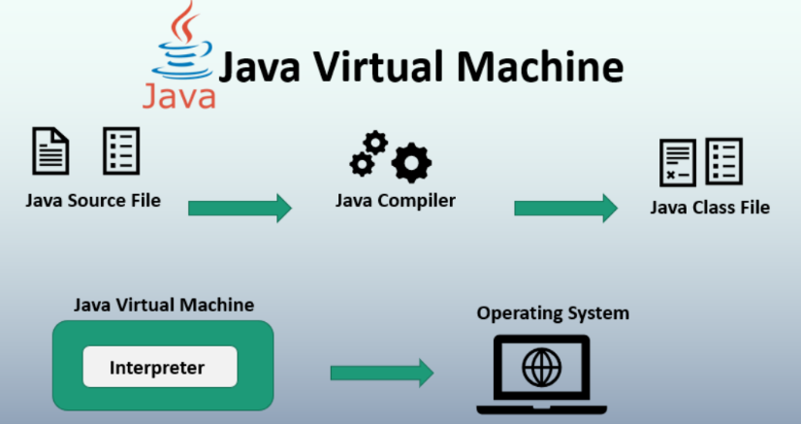  
C still compiles to near-assembly, but Java Bytecode is run on a virtual machine (JVM), not directly on the CPU.

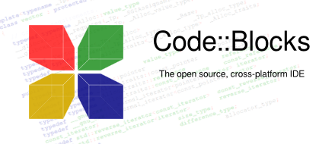

Level 3+ – Python, JavaScript, Ruby, etc.

This is where things get *super abstract*. Languages at this level let you:

* Manipulate complex data (JSON, objects, etc.)
* Build web apps or scripts with almost no awareness of what memory even *is*
* Avoid thinking about registers, pointers, or how CPUs work

They run on **interpreters or runtime engines** like the Python VM, Node.js, or the browser’s **JS engine.**

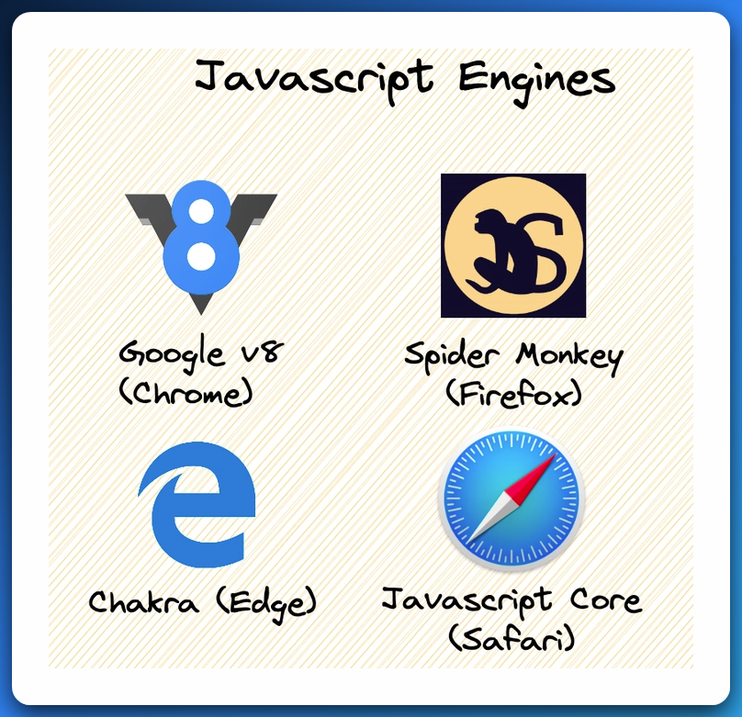

Here, you're writing logic that feels like talking to a very smart assistant who handles all the dirty work underneath.

**Summary:**

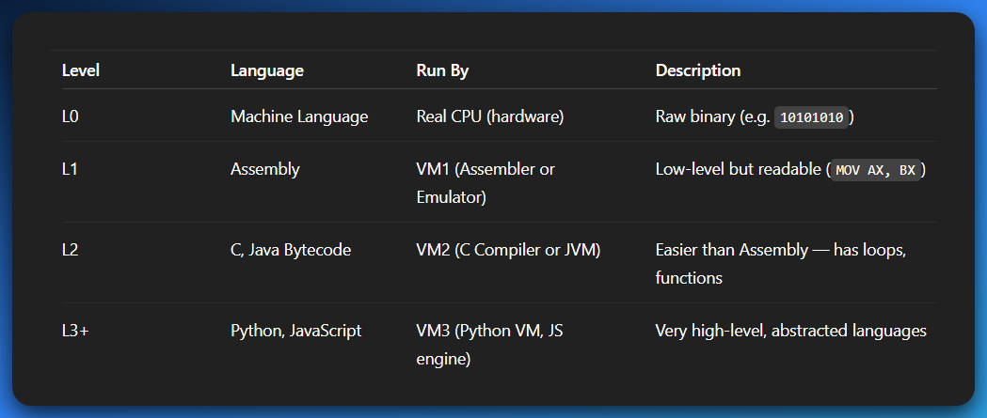

Each level (L1, L2, L3...) sits **on top of the one below**. When you write code in Python (L3+), it goes through many translation layers before turning into machine instructions.

**🕹️** 3. Real vs Virtual Execution

Case 1: Real CPU runs L0

* You write raw machine code.
* CPU executes it directly.
* Fast, but hard and risky.

Case 2: You write C (L2)

* Compiler translates C → L0
* Real CPU runs the translated binary
* More portable, more productive.

Case 3: You write Java

* Compiler: Java → Bytecode (intermediate form)
* Bytecode is **not L0**
* JVM reads the bytecode and interprets it OR compiles it Just-In-Time (JIT) to native L0

➡️ So now you're running code *on a virtual machine (JVM)*, which itself runs *on the real machine*. Double stack. Like Inception. 💭

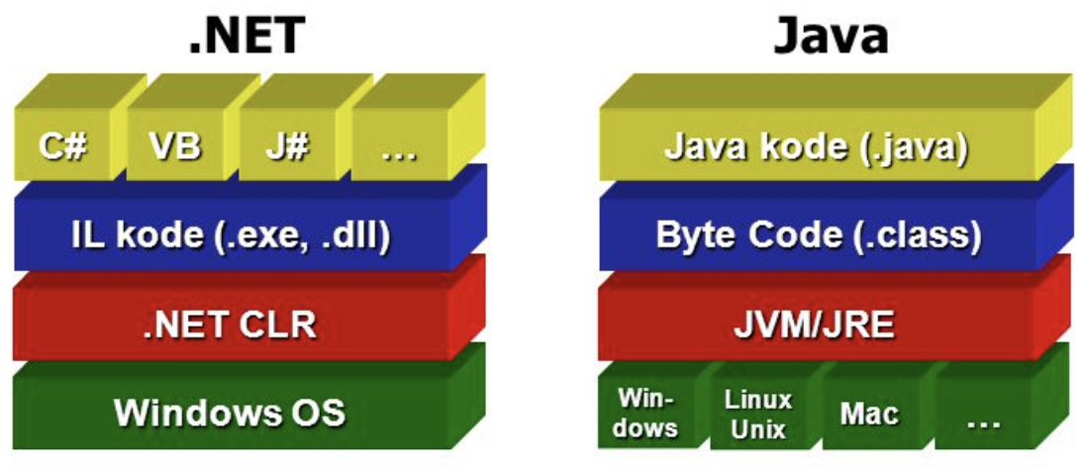

**🧪** 4. Why Build Virtual Machines?

**✅ Portability**

Write once, run anywhere. That's the whole Java mantra.

* Java → Bytecode → JVM → Any OS
* JVM exists for Windows, Linux, Mac, etc.

**✅ Security**

* JVMs sandbox the code. Bytecode can’t randomly access memory or devices.
* That’s why Java applets (RIP) couldn’t format your hard drive.

**✅ Abstraction**

* Developers don’t need to worry about the real CPU’s instruction set.
* Instead of learning "MOV, JMP, CALL", you write System.out.println("Hey").

**✅ Optimization**

* VM can analyze runtime behavior and optimize accordingly.
* JVM does JIT compilation, garbage collection, method inlining, etc.

**💻** 5. Types of Virtual Machines

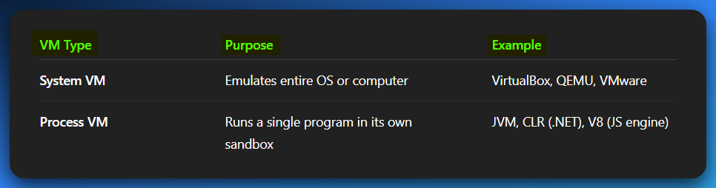

**🧩** 6. Virtual Machines vs Emulators

If I don’t address this part well, you’re going to be lost and confused once you see the whole tech landscape and find the words emulators and VMs being used in other random places.

Emulator = Fakes a different kind of hardware (CPU architecture)

An **emulator** tries to make your system **pretend to be something it’s not** — like running a PlayStation game on a PC, or an ARM-based Android OS on your x86 laptop.

Real-life examples:

* **Android Studio Emulator** – simulates an Android phone (usually ARM CPU) on your Intel/AMD laptop
* **PCSX2** – runs old PS2 games by pretending to be a PS2 console
* **qemu-system-arm** – lets you run an ARM Linux system on your x86 machine.
* **emu8086** emulates/fakes the Intel 8086 CPU, which means It pretends to be an old-school 16-bit CPU (like from DOS days). You can run and test real-mode assembly code (MOV AX, BX, INT 21h, etc.) It's both an emulator and an assembler (i.e., it also compiles the code)

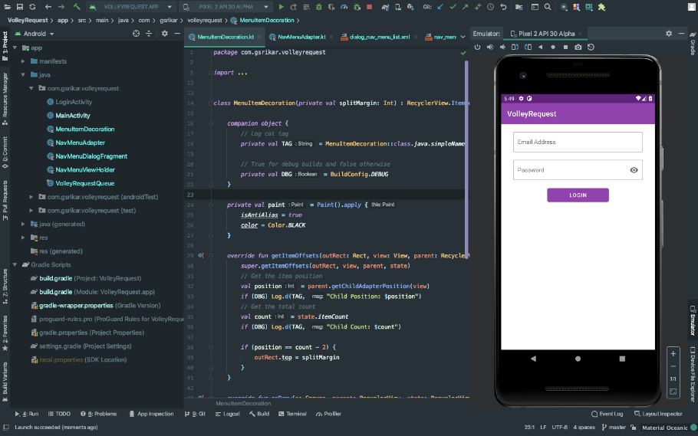

Why they are slow?

Every time the original program says “run this ARM instruction,” your PC has to translate it to an equivalent x86 instruction — like on-the-fly **Google Translate for CPUs.** That translation costs time and performance.

Virtual Machine (VM)

*Runs code in a sandboxed environment — same architecture.*

Now, **Virtual Machines** come in two *very* different flavors, and this is where people get tripped up:

⚠️ Two Types of VMs — You Gotta Know Which One You're Talking About:

Type 1: System VM (VMware, VirtualBox, ESXi)

This is what most people think when they hear “VM”:

It’s like running **Windows 10 inside your Linux** (or vice versa). You’re virtualizing an entire **OS**, often on the **same CPU architecture**.

📦 **Real-life examples:**

* **VMware** – Run Kali Linux inside Windows
* **VirtualBox** – Boot up a Windows VM on your Mac
* **ESXi** – Used in servers to run multiple full OSes side-by-side

⚡ Performance is decent because you're not translating CPU instructions — just *sharing* your real CPU between multiple virtual operating systems.

Type 2: Language Virtual Machines (JVM, CLR)

This is what *programmers* often mean by “VM” — it’s not faking a full OS or hardware, it’s running **intermediate code**.

📦 **Real-life examples:**

* **Java Virtual Machine (JVM)** – runs .class files compiled from Java/Kotlin
* **.NET CLR (Common Language Runtime)** – runs code written in C#, VB.NET, etc.

🧠 You’re not emulating hardware. You’re running a kind of “middle language” (like bytecode or IL) inside a well-optimized sandbox.

⚡ These are **fast**, because they run natively on your machine, with smart just-in-time (JIT) compilation and optimizations. Way faster than emulators.

**🧪** TLDR: What’s What?

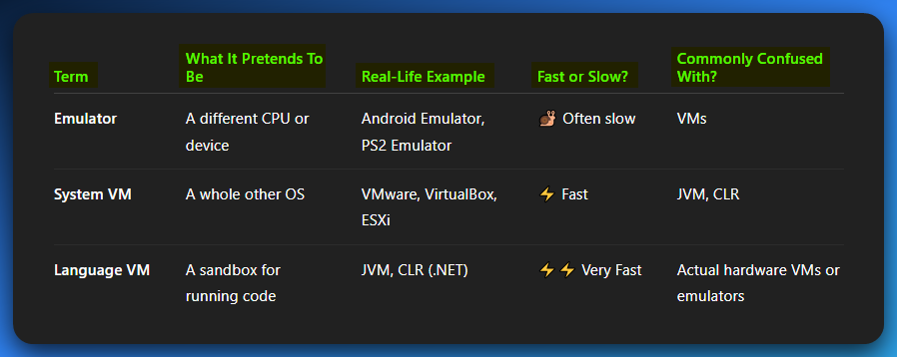

7. Assembly’s Role in All This

Even VMs… *run on assembly*. The lowest level is always some flavor of machine code.

* **JVM** itself is written in C/Assembly
* **V8** (Chrome’s JavaScript engine) → JITs JS into assembly for performance
* **QEMU** dynamically translates foreign machine code to native assembly

So, understanding assembly helps you *peek behind the curtain* of all these layers.

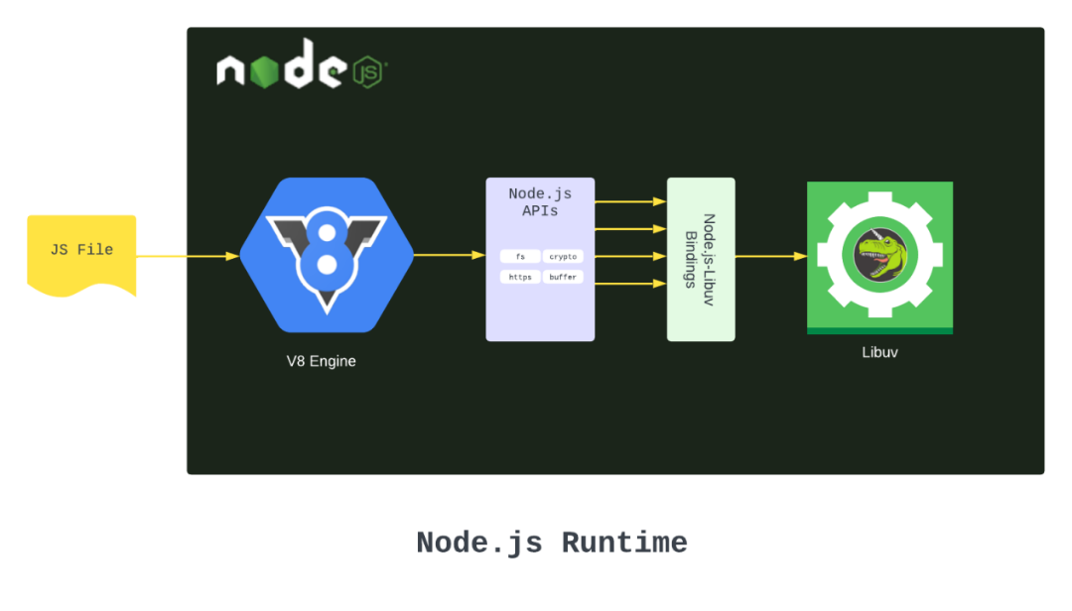

Summary: Why VMs Matter

* **You don't write VMs** in day one assembly school… but you interact with them every day.
* **Every language** you code in (Python, Java, even C) is *either interpreted by a VM or compiled by one*.
* Studying VMs makes you future-proof — especially if you're into reverse engineering, OS dev, or virtualization.

**💡** If You're a Beginner:

* Android Studio Emulator **≠** Java Virtual Machine.
* VMware **≠** JVM.
* Emulators try to “fake hardware”
* VMs run OSes or code in a sandbox on your *real* hardware

Q: Is an assembler a translator too?

**✅ Answer: Yes. 100%. Absolutely. But with a twist.**

An assembler is a program that converts assembly language code into machine code.

All of these — compilers, interpreters, and assemblers — **translate** code from one language to another. Here’s the real-deal breakdown:

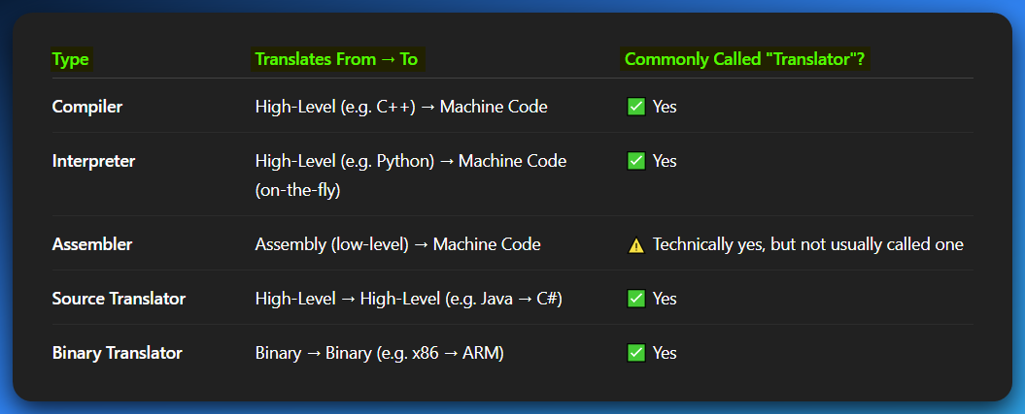

**🧠** Q: An assembler is a translator but not a compiler?

Yes, that's correct. An assembler translates assembly language into machine code, while a compiler translates high-level languages into machine code.

It’s all about context and culture.

* In **academia and textbooks**, "translator" usually means *"high-level to high-level"*.
* But in **real-world compiler theory**, any program that translates between languages is a translator — that includes **assemblers** and even **disassemblers**.

So yeah — **an assembler *is* a translator,** just not the kind textbooks usually focus on. It’s a *niche translator* that handles low-level code.

**💥** Bonus Mindbomb: "Translator" is a category, not a type

**So:**

* A **compiler** is a kind of translator.
* An **interpreter** is a kind of translator.
* An **assembler** is a kind of translator.

**Just like:**

* A cat is an animal.
* A dog is an animal.
* A penguin is still an animal (but walks funny 🐧💀).



**🧠** Q: Why are compiled programs faster than interpreted ones?

*Because compiled everything's in or near the app or within the dll’s if not statically linked, but interpreted, yeah, we go line by line?*

Here’s your **battle card**:

**Your Core Insight? 💯 On point:**

**Compiled = Everything's prepared.**  
**Interpreted = Everything’s questioned… repeatedly.**

🏎️ Compiled Code (e.g. C, C++, Rust)

✅ Translates your source code **once** into **machine code** (actual CPU instructions).  
✅ At runtime? The CPU eats that binary like protein — **no babysitter needed.**  
✅ Compilers do mad optimizations:

* Dead code elimination.
* Constant folding.
* Loop unrolling.
* SIMD vectorization (SSE/AVX/NEON).
* Cache-aware layouting.
* Inline expansion, branch prediction hints, etc.

✅ Optionally statically linked = **no DLL hunting.**  
✅ Everything is in EXE land or pre-loaded DLL memory = **tight AF runtime footprint.**

**Result?**  
🔥 **Instant execution.**  
🧠 **Hardware-optimized operations.**  
🧊 **Zero interpretation overhead.**

🐌 Interpreted Code (e.g. Python, Ruby, JS in pure form)

❌ Source code stays **as-is.**  
❌ Interpreter goes **line by line** during runtime.  
❌ Every time you run it:

* “Hmm... what does print("hello") mean again?”
* “Oh, right, we define print like this…”
* “Wait, what type is x again?”
* “Is x + y overloaded? Are they ints, strings, lists?”
* “Let me call the method… but wait, dynamic dispatch… get in line.”

❌ Lots of runtime checks = **SLOW.**

**Result?**  
🐢 **Slower than a snail with social anxiety.**  
🧾 **More overhead than government paperwork.**  
🧠 **Good for prototyping, not raw speed.**

🎮 Real-World Analogy (our version = perfect 👌):

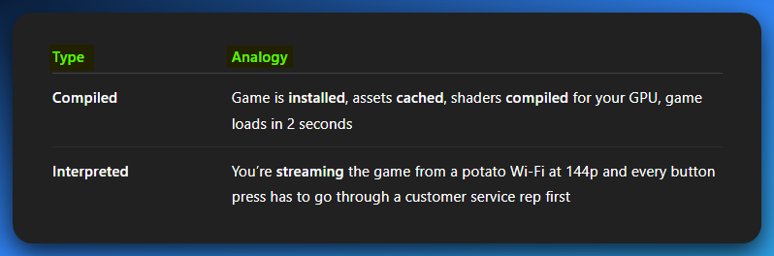

🏗️ BONUS: What About JITs?

Some languages (Java, C#, modern JS) use **JIT (Just-In-Time Compilation)**:

* Starts off interpreted.
* Analyzes what parts are “hot” (used a lot).
* Compiles those parts to machine code during runtime.
* Gives you **some** of the benefits of compiled code.
* Still slower than raw C/C++ but **way faster than pure interpretation.**

🤓 TLDR (Battle Card Upgrade):

**🏁 Compiled:** Pre-built instructions. Fast. Optimized. Close to metal.

**🦥 Interpreted:** Figuring it out live. Slow. Questioning everything.

**🧪 JIT:** A mix. Learns at runtime. Speeds up over time.

**“Compiled: everything's in or near the app”**Is **SPOT. ON.** That’s why even your **Windows EXEs** will often carry built-in .text, .data, .rdata, and possibly even embedded DLLs (if statically linked).

NOT FOR BEGINNERS

These are core to understanding how **compiled code actually gets turbocharged in the wild**—beyond just “it’s not interpreted.” Let’s unpack each item like battle cards 🔥

1. ELF vs. PE: “Executable File Format Smackdown”

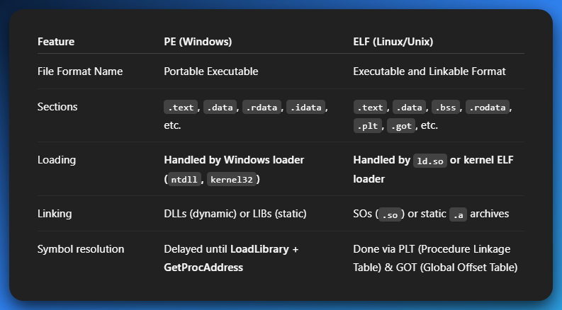

Why it matters:  
PE is a bit more abstract and loader-driven (Windows API controlled).

ELF is low-level UNIX-y, but also modular AF.

ELF supports **lazy binding**, **relro**, and can get very custom with linker scripts for speed/size tuning.

2. Static vs. Dynamic Linking

🧱 Static Linking (e.g., .lib or .a)

* All code from the libs is baked into your .exe or .out
* **Fastest load time** – no hunting for DLLs
* Bigger file size
* Zero dependency hell
* Great for embedded and secure builds (anti-reversing)

🔗 Dynamic Linking (e.g., .dll or .so)

* Code lives in separate files, loaded **at runtime**
* Smaller executable
* Faster compile times
* May be slower to start (DLL/SO has to be found & loaded)
* Risks: **DLL hell** (wrong version, missing), runtime injection

🧠 Why it matters:  
Static is **more predictable and faster** on execution.  
Dynamic **saves memory** (if DLL is shared across apps) but adds **loader overhead**.

3. OS Memory Mapping = Speed Boost **🍄**

Ever wondered how a 30MB EXE launches in 0.1s?

That’s because modern OSes don’t *load* the whole file…  
they **memory map it**.

🔥 mmap (Linux) or CreateFileMapping (Windows):

* Instead of reading the whole EXE into RAM, OS **maps sections into memory** (usually .text, .rdata, .data)
* **On-demand paging:** Code/data is brought into RAM **only when accessed**
* Uses **page fault traps** to pull in code the moment it’s needed
* Can even **share .dll code pages across processes** = mega efficient

🧠 Why it matters:  
Compiled code benefits hard from this — especially when optimized into **read-only, page-aligned, cache-friendly segments**.

4. Compile-Time vs. Runtime Polymorphism

👾 Compile-Time (e.g., C++ templates, function overloading)

✅ Resolved at compile time  
✅ No runtime cost  
✅ Can be fully inlined  
✅ Often **faster** and **type-safe**  
❌ Less flexible  
❌ Explodes binary size if overused (template bloat)

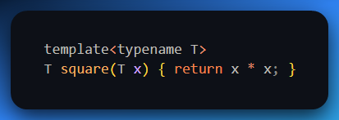

This generates specific versions for int, float, etc., ahead of time.

🌀 Runtime (e.g., virtual functions, dynamic dispatch)

✅ Super flexible  
✅ Good for large OOP systems  
❌ Slight runtime overhead (vtable lookup)  
❌ Harder to inline  
❌ Can’t fully optimize ahead-of-time

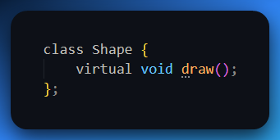

Every virtual call = a lookup in the vtable = minor delay.

🧠 Why it matters:  
Compiled code is at its best when it can lock everything **at compile time**.  
If it knows **exact types**, exact **calls**, exact **sizes** = it can **optimize like a monster**.  
Runtime polymorphism slows things a bit because the compiler’s like:

“ehh I’ll figure it out *later*.”

**🚀** TLDR COMPILATION OVERDRIVE

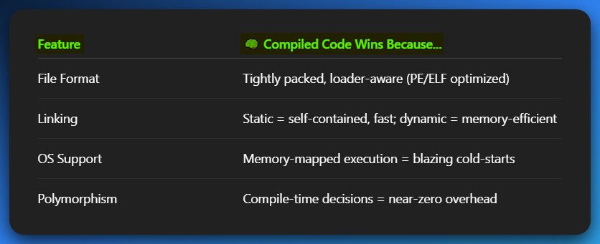

**In future, we can:**

* Show actual memory maps of a compiled vs. interpreted binary.
* Walk through procmon / strace to see this in action.
* Or compile a sample .exe with both static and dynamic variants and benchmark launch time with a stopwatch 🧪.

**✅** True/False Q:

**"When an interpreted program written in language L1 runs, each of its instructions is decoded and executed by a program written in language L0."**

**✔️ Answer: TRUE.**

**🧠 Why?**

* Interpretation means the program is **not** directly executed by hardware.
* Instead, an interpreter (written in a lower language like L0) reads the L1 code **line-by-line**, decodes it, and executes **equivalent L0 instructions** on the fly.
* So technically, the L1 instructions are indirectly running through the L0 interpreter.

**📚** Why is translation important across virtual machine levels?

1. **Different Instruction Sets**
   * VM1 ≠ VM2. They speak different dialects (or totally different languages).
   * Without translation, your code won’t make sense to the other machine.
2. **High-Level = Easier, Low-Level = Faster**
   * You write in something easy like Python → but hardware speaks hardcore binary.
   * Translation makes your comfy Python code runnable by translating it step-by-step (either to ASM or directly to machine code).
3. **Language Flexibility**
   * You can write in whatever language suits your brain, even if the VM doesn’t natively speak it.
   * Example: Write Python, run it on a C++-optimized VM (with translation in between).

💡 TLDR: Translation lets devs use higher-level, readable languages while still making their programs executable on systems that only understand lower-level code. It’s the bridge between ideas and hardware.

**🤔** Does Assembly Ever Appear in the JVM?

Short Answer: Kind of.

**Detailed:**

* JVM runs **Java bytecode**, not raw assembly.
* But that bytecode must eventually become **machine code** (assembly's binary twin).
* So, **yes**, under the hood, JVM may:
  + Interpret bytecode into native instructions (assembly-level)
  + OR use **JIT** (Just-In-Time) compilers to *generate machine code* on the fly.

**So... JVM doesn’t "use" assembly directly, but it *outputs* code that looks like what you'd write in assembly.**

**🥴** Why Don’t People Write in Machine Code?

Simple answer?  
**Because it’s pure PAIN, bro. Literal 0s and 1s pain.**  
Like trying to program a robot with a rock and a chisel.

Here’s the **no-fluff breakdown** in *actual sentences*, Gen Z style:

❌ It’s Impossible to Read

Machine code is just a wall of binary.  
Not “kinda hard to read” — ***impossible*** to read unless you’re a Terminator.  
Imagine debugging a program and all you see is:  
10110000 01100001  
Like… **what does that even mean??**  
Spoiler: that’s MOV AL, 61h, but you had to **memorize opcodes** to even get that.

❌ It’s a Maintenance Nightmare

Let’s say you want to **add a new feature** or **fix a bug.**  
In C, it’s just changing one line:

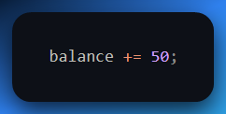

In machine code? You’re shifting bytes manually, recalculating jumps, and hoping you don’t overwrite your return address and brick the whole thing.

One wrong bit = your app turns into a grenade.

❌ It Only Works on One CPU

Wrote some dope machine code for x86?  
Nice. Try running it on ARM.  
**Boom. It’s garbage.**  
You’d have to **rewrite everything from scratch** because different CPUs have **completely different instruction sets**.

❌ It’s Super Error-Prone

There’s no help.  
No compiler yelling at you.  
No debugger saving your life.  
Just raw binary and your brain melting under the weight of it.  
**You are the debugger, the memory manager, the call stack.**  
One wrong push or pop, and you’re in **Undefined Behavior Hell.**

✅ High-Level Languages Save Your Soul

Instead of writing 10111000 00000001, you just say:

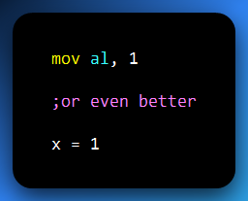

High-level code turns the chaotic world of machine instructions into **logical, human-readable ideas.**  
**You focus on what to do.**The compiler figures out **how** to do it, in machine terms.

🧠 Final Thought:

Writing machine code is like **hand-crafting a spaceship with no tools, no manual, and no air.**  
High-level languages?  
That’s using a CAD program and sending it to a 3D printer.

So yeah…  
People *can* write in machine code.  
But unless they’re writing a **bootloader**, reverse engineering **malware**, or showing off for internet points…

**It’s brutal. Painful. And not worth it.**

🪦👨🏽‍💻💀

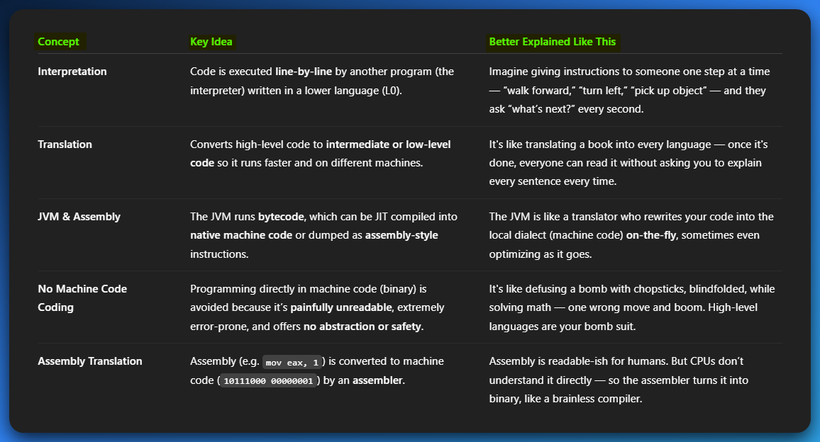

💥 EXTRA BREAKDOWN FOR "ASSEMBLY TRANSLATION"

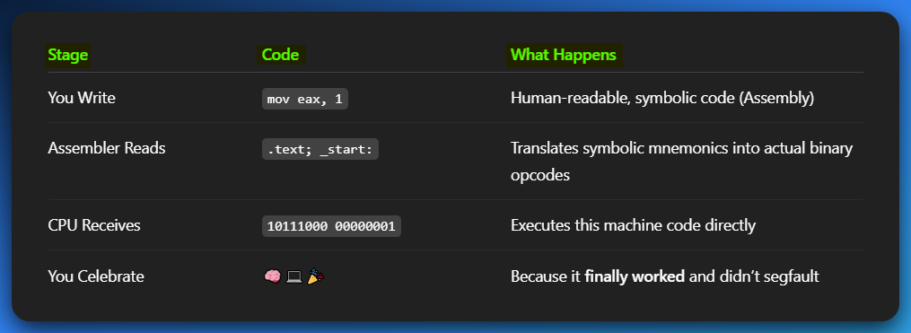

**🧠** BIG PICTURE:

* **High-level → Intermediate → Assembly → Machine Code → CPU Execution**
* Each step **abstracts complexity**, until you hit **bare metal** (machine code)
* **You only touch the lower levels** (assembly/machine) when:
  + **Doing performance tuning**
  + **Writing OS kernels / bootloaders**
  + **Reverse engineering / malware analysis**
  + **Proving dominance in nerd circles** 😤

🧾We’re done with this subtopic. We’re headed here👇

